

Federated Architecture Program Iteration 2
Strategy and Planning Team

Business Design for

Common IT Infrastructure Programs

Version 1.0 DRAFT

Version Control

Version | Date Released | Summary of Changes
DRAFT 1.0 | January 23rd 2003 | Initial version

Table of Contents

Introduction to this Document……………………………………………………4

Other Common IT Infrastructure Programs
Service Model……………………………………………………………..……7

Secure Channel
Service Model…………………………………………………………………..13

Implementation Analysis ………………………..……………………………..20
Program Service Alignment Model Example…………………………..………27
Performance Model Example ………………………………………..………...30

Possible Next Steps…………………………………..…………………………..34

Appendices
- Definitions
- Program and Service Modeling
- Service Output Types
- Secure Channel Performance Model –Network and Security Services
- Secure Channel Implementation Analysis
- Comparison of Service Broker and ebXML

Introduction to this Document

This document presents a portion of a business design for GoC common IT infrastructure services, in the form of specific strategic business models. The method used to produce the models is part of a more comprehensive methodology for business design that the Federated Architecture Program (FAP) Strategy and Planning Team has been refining over the past few months.

The intended result of strategic business modeling is to present a standard view of the design of programs and their associated services in a simple and consistent form that can:
- represent key elements of a business design that are important to policy, program and service managers - in a simple form for validation and alignment within a whole-of-government context,
- be aligned with models of other related programs and services,
- be translated into more detailed models, designs, and views of various forms for project planning and implementation, and
- be used as a “master design” enabling on-going progress reporting and design review of the implementation.

These models for common IT infrastructure will contribute to and become part of a set of larger models describing the strategic business design of the GoC, called the GSRM (GoC Strategic Reference Models) to be developed over the next year. The GSRM is described in the GSRM White Paper Version 3.0.

For reference, the following table shows the coverage of design information in this document relative to the planned contents of the GSRM.

GSRM Business Content | Common IT Infrastructure Models  (covered in this document)
Information | No
Services | Yes
Business Locations | No
Stakeholders | Examples
Business Events and Cycles | No
Programs, Needs, Goals and Performance Metrics | Examples
\

Because this document uses a new modeling method, a few brief notes are provided in the body of the document to help the reader, and additional information is provided in the Appendices.

Scope and Approach

Common IT infrastructure services are defined generally as those offered to all parts of the organization equally, and deriving from general resources – networks, storage and processors - and meeting general needs – security, data conversion between devices and applications, and so forth. Large organizations evolve specific services depending on the interpretation of general needs.

For this model, common IT infrastructure services are defined to be those available now or planned for offering by the following programs and initiatives:
- “Other Common IT Infrastructure”
  - GENet (Next Generation Government Enterprise Network)
  - FINDS (Federated Infrastructure National Directory Service
  - SAKMS (Common PKI Services Project)
  - IDC (Intrusion Detection Centre Project)
  - PKITF (PKI Technical Framework Project)
  - CMHS (Classified Message Handling System Project)
- Secure Channel

The material in this report was prepared primarily from documentation on each of the included initiatives.

The Secure Channel models were based on the vision set out in Architecture and Design Specifications (ADS) Volume 1. The models are not intended to replace the ADS document, but to elaborate the business vision in a standard way.

Architects from the Secure Channel (SC) participated in discussions to describe the SC services, and provided information on implementation. There have been changes to the original vision introduced in SC implementation builds, but these have not been reflected in this document.

Note on Model Analysis

In this document, the Secure Channel and “Other Common IT Infrastructure” models are presented separately. This document does not make a detailed comparison between the two, but provides general contrasting observations and sets the stage for more detailed analysis.

Service models are generally used to optimize a business design by analyzing processes in each service using patterns to determine where common processes could be handled more efficiently. This document does not attempt to carry out this procedure – the analysis is primarily descriptive and explanatory.

Service models lend themselves to comparison with patterns of service from other sources. No attempt was made at this time to compare the GoC common IT infrastructure models with patterns from other sources.

Format of the Common IT Infrastructure Service Models

Diagrams for both “Other Common IT Infrastructure Services” and the Secure Channel are shown separately. Each model is presented on three “pages” using similar themes, to simplify the diagrams. The themes are generally useful for any service model.

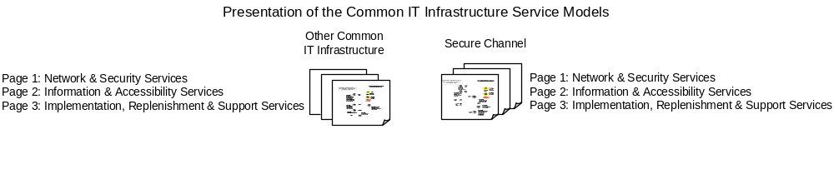

As shown in the above the three pages and themes are:

- Network and Security services are types of mFulfillment – Basic Services
- ission-critical fulfillment services – central to the mission of the program (common IT infrastructure) and used routinely by program clients as part of their own fulfillment chain.

- Information and Accessibility services are types of
- a
- dded-value fulfillment services – building on or going beyond the mission of the program, but still used by program clients as part of their fulfillment chain.

- Implementation, Replenishment and Support services are types of p

- rovisioning services - these services accomplish three tasks:
    - preparing clients to take up the services of the program,
    - provisioning and replenishing the program’s services for continued operation, and
    - developing and protecting the resources and assets of the program.
They are not fulfillment services in the sense that clients do not use them routinely as part of their own fulfillment chain.

Some services will appear on more than one page of the model, in order to show continuity.

Note on Service Model Symbols (SDM-2)

Service models have several forms depending on the information to be presented – the following is called Service Design Model View 1 (SDM-2); it presents an integrated model of services, outputs and horizontal accountability relationships between services.
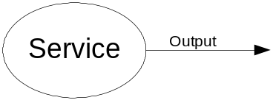
In the model, an ellipse stands for the service and an arrow (called the output vector) stands for the output of the service.

The vector can go either to the public (the default) or another service but not both. Only one type of output per service is allowed, although it may go to several recipients. If the vector goes to a service, there must be two or more independent implementations of that service to justify its existence.

A vector in this model does not represent the flow of an output between parties – it represents the agreement (explicit or implicit) between two parties for the production of the output.

To simplify the presentation of a service model in diagram form, services with outputs of the same type, and relationships are grouped together. The group is called a Service Group and a note in the model lists the actual services in the group.

By convention, only one output vector from any service is named to simplify the appearance of the model, but all vectors from that service have exactly the same name.

…
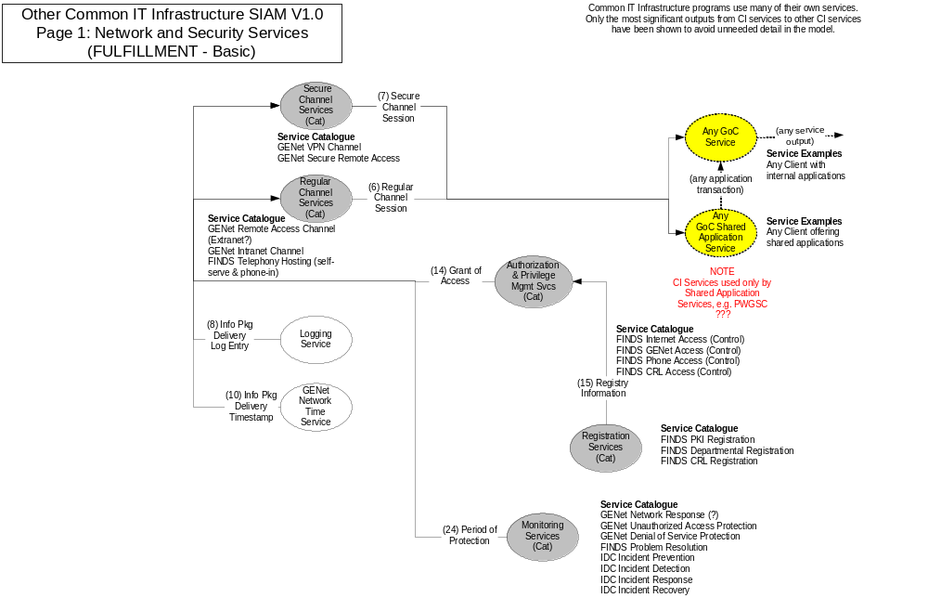
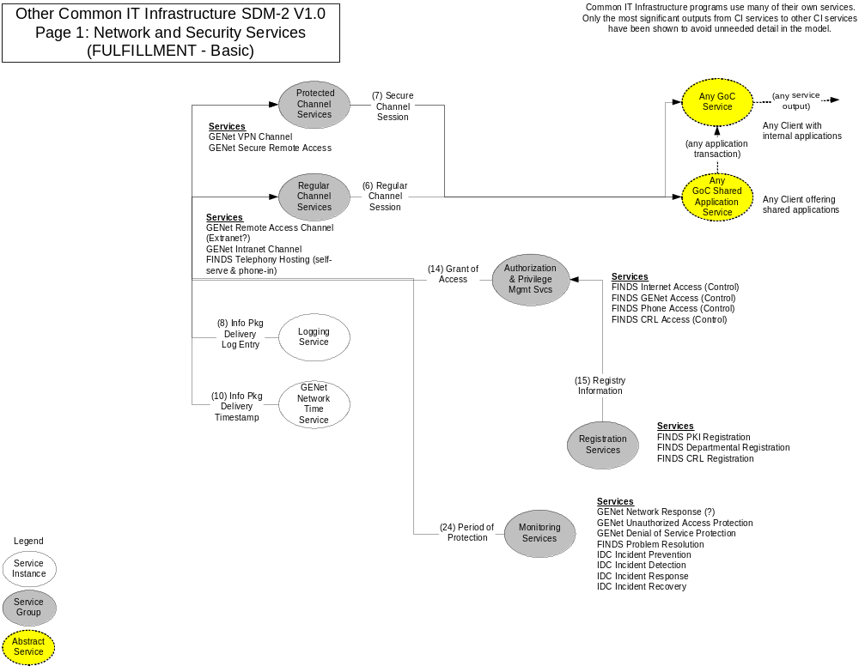
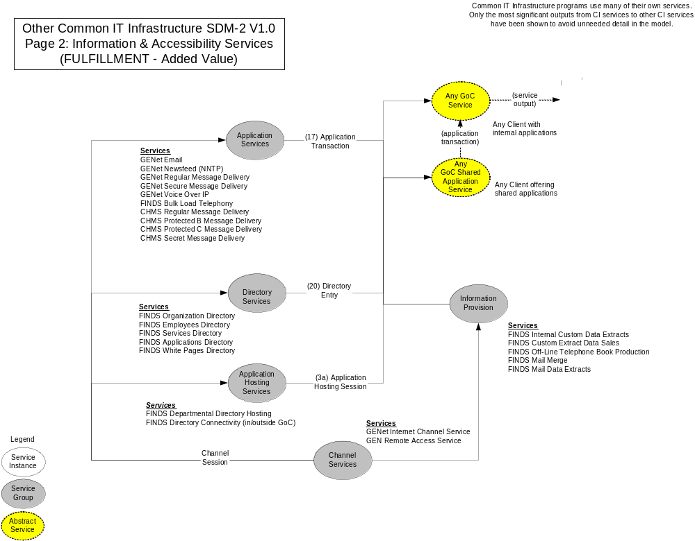

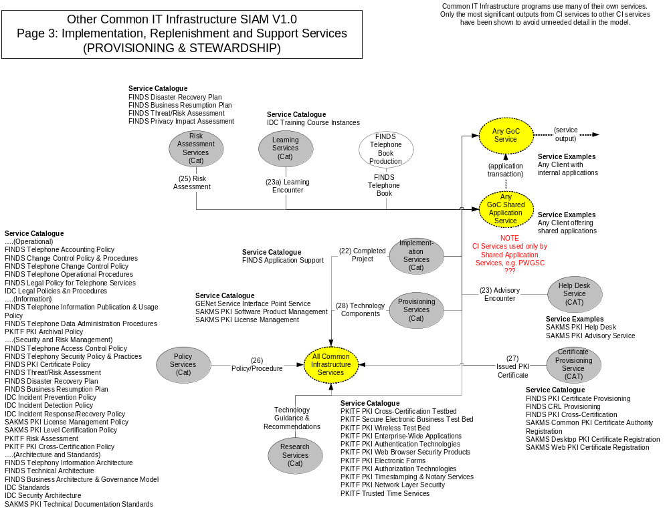
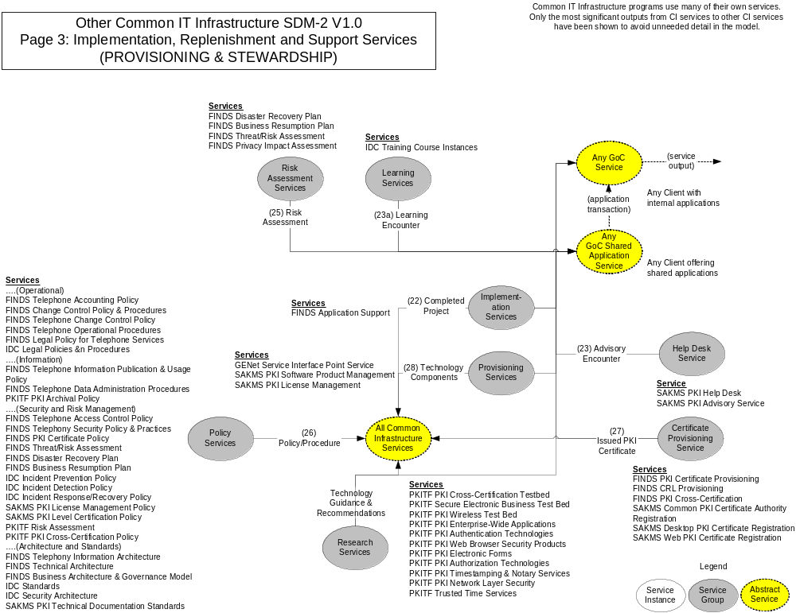

Remarks and Observations – Other Common IT Infrastructure Service Model

The model reflects a consistent and leveled view of services according to the standard definition proposed by the GSRM. The model was prepared from documentation and has not been validated.

General

As would be expected, all services in this model are services to providers according to the definitions of the GSRM. No service appears to be accountable directly to a member of the public as the GSRM defines horizontal accountability.

One important observation is that the program client(s) in a service model for any common IT infrastructure program are application services providing application transaction outputs to other services, or a process inside a service using an application. These are the only situations where the means exists to use the outputs of common IT infrastructure services. This has been modeled as a pattern that includes both a generic shared application service provider and a generic service provider (with applications inside the service) to enable consistent linkage with other service models.

Page 1 – Network and Security Services

Two groups of channel services address connectivity – their outputs are “uses” of a channel or channel sessions. The regular channel services offer basic (“lowest common denominator”) connectivity, and the protected channel services offer a higher level of security for the connection.

Use of the channel services is controlled by authorization services that grant access. Registry services provide the information on which the grants of access are based.

Protection services monitor channel operation and intervene when needed.

Page 2 – Information and Accessibility Services

There are a substantial number of application services providing specific types of functionality, and application hosting services that host client applications. There are also directory services providing access to specific types of information directories, but it was not clear whether FINDS is fully accountable for the directory information outputs, or only for the application hosting of directory information provided by other services, so both interpretations have been shown

FINDS also provides added value information outputs in several forms (e.g. extracts from directories, telephone books).

Page 3 – Implementation, Replenishment and Support Services

Typical services are offered to both clients and the providers of common IT infrastructure services – planning, policy-making, training, help and assistance, provisioning of technology, implementation assistance. A number of PKI research and PKI provisioning services are also available.

Apparent Overlaps

Most of the services appear in groups – not surprising considering the variety of programs and initiatives that have been aggregated together in this model. This does not necessarily mean there is redundancy in a group, only that services in a group produce similar types of outputs for similar clients. This would normally lead to a rationalizing step in business design where the processes of these services are examined to convert similar processes into new shared services, but as was pointed out in the introduction, this level of optimization has not been carried out.

There does appear to be some examples of redundancy however. For example on Page 2, in the Applications Services group, GENet Secure Message Delivery and CHMS Protected B, Protected C and Secret Message Delivery appear to overlap. However, this document should be considered only an illustration of the quick forensic use of a service model to highlight areas of possible redundancy in a simple rules-based manner. No attempt has been made to list the redundancies, validate them or elaborate the model to examine them further.

The model does not distinguish implemented from un-implemented or replacement services because the required information was not gathered. This is not difficult to do (was in fact done for the SC model). If this information was gathered and applied, some apparent redundancies might be explained.

Apparent Gaps

Gaps, i.e. missing services, cannot be identified in a disciplined manner without more work. One approach to gap analysis is to compare the model with typical patterns or baseline models of service types for a given program type – in this case for IT infrastructure programs. For example the IT Infrastructure Library (ITIL) offers service descriptions for some types of infrastructure service.

The other approach to gap analysis is to develop other views of the service model – for example, the analysis of target groups, needs, outputs and outcomes offered by a Service Design Model View 1 (SDM-2). An illustration of this view is provided later in this document for Secure Channel only.

In summary, the work on this model to date offers general insights, points to areas to be explored, and sets the stage for further analysis.
.
Other observations of the model will be made following the presentation of the Secure Channel model, where some contrasts can be made.

Secure Channel Service Model

The Secure Channel service model is presented on the following pages, using the same themes as the Other Common IT Infrastructure model.
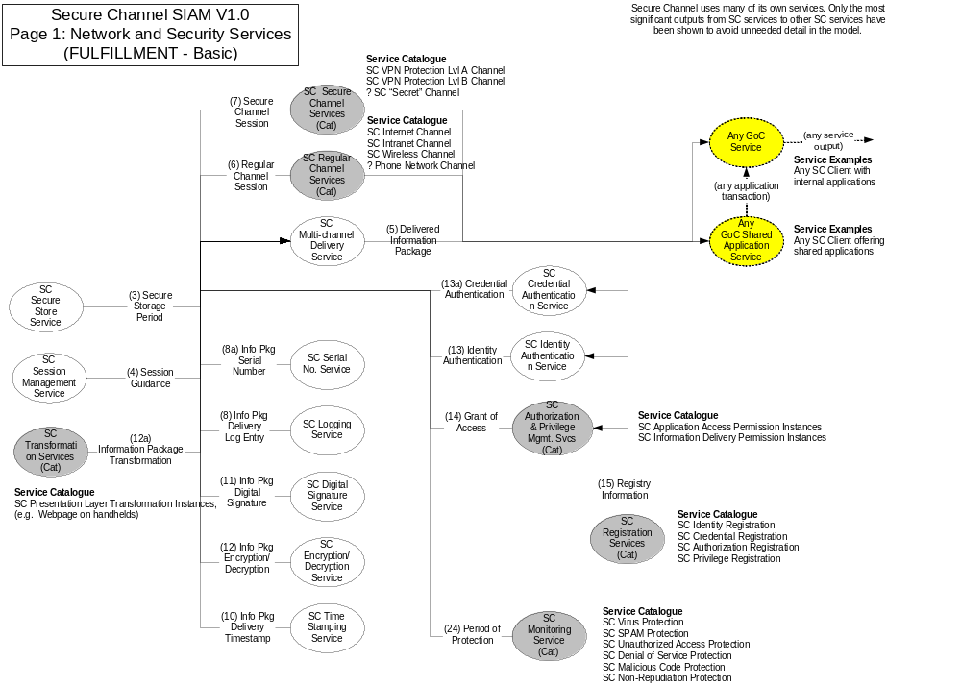
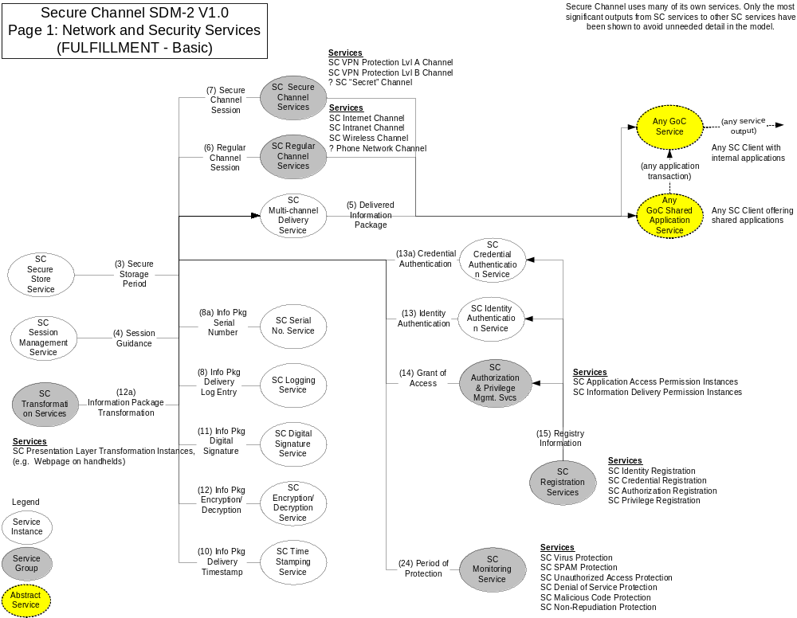
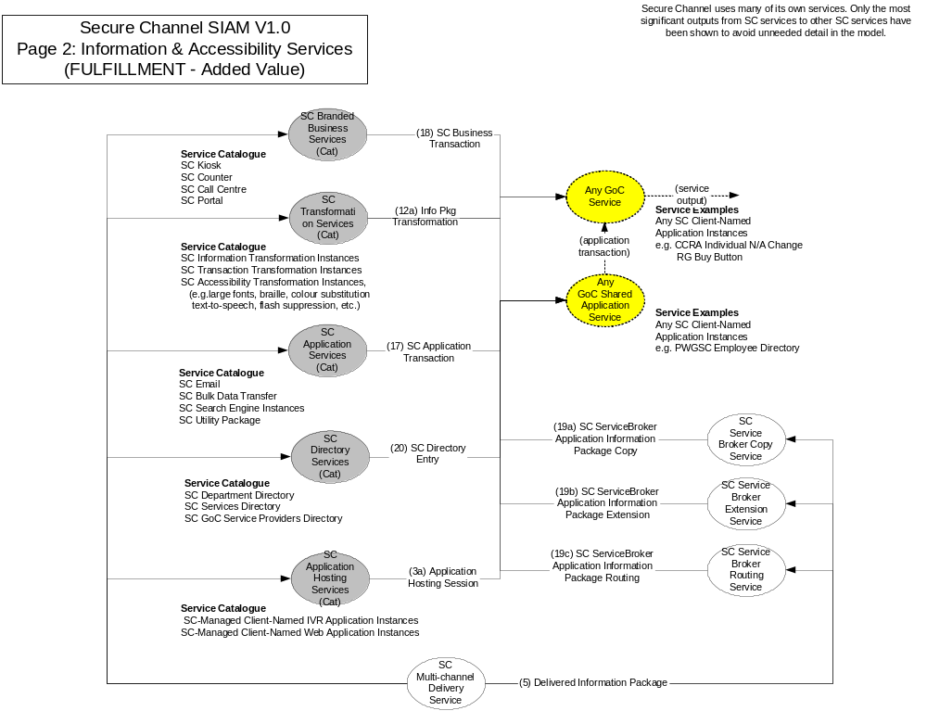
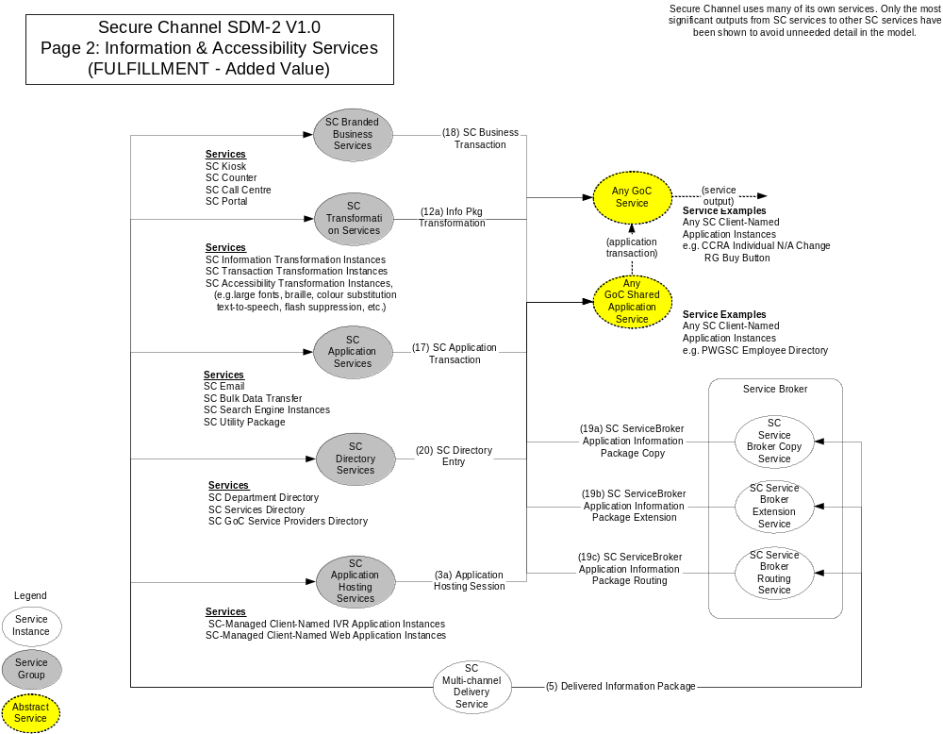
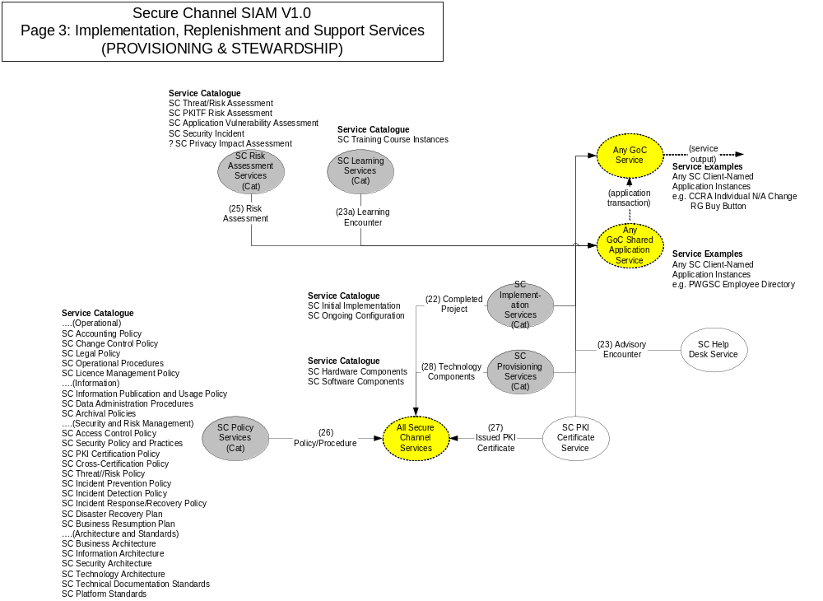
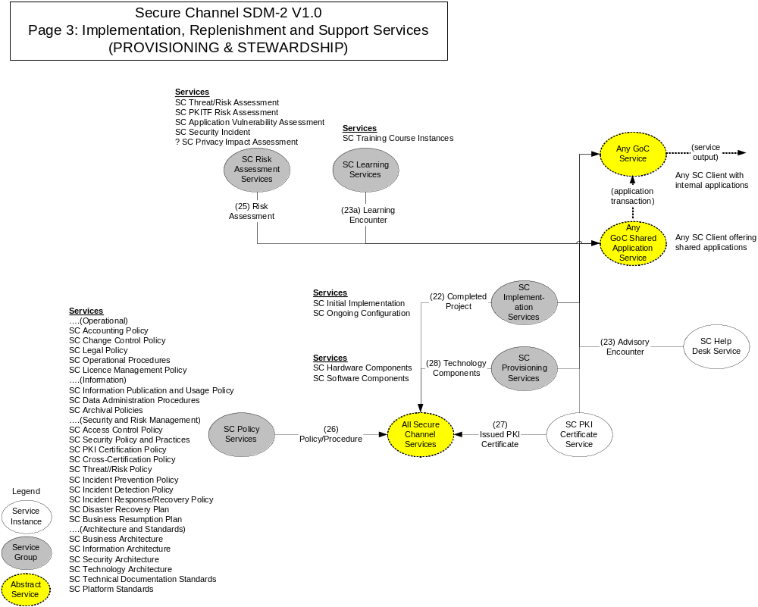

Remarks and Observations - Secure Channel Service Model

The model reflects a consistent and leveled view of services according to the standard definition proposed by the GSRM. The model was prepared primarily from documentation but with the help of Secure Channel architects. A lesson learned was that preparing these models in a workshop setting with knowledgeable business analysts and designers could be expected to yield better interpretations and more important insights, more quickly.

General

Secure Channel’s services are all services to providers – the SC providers are accountable to other providers for their outputs. There are no cases where SC is accountable to the public for its outputs in the model.

Secure Channel goes beyond the typical resource-based concept of common IT infrastructures in the areas of multi-channel delivery and the Service Broker. These observations are based on the fact that common IT infrastructure services offer connectivity, which can be equated to offering a road between two locations, but the features of the Service Broker and the Multi-Channel service can be equated to a postal service.

Page 1 - Secure Channel Network and Security Services:

The Multi-Channel Delivery Service is a major feature of the Secure Channel program, distinguishing it from other IT infrastructure programs. This service uses its channel services to offer delivery of an information package across multiple channels, including the capability of interrupting a transaction in progress on one channel and continuing it later on another.

From a client’s point of view the Secure Channel security services appear as features of basic information delivery. For example, information delivery can be “ordered” with any one or more of:
- “Regular” channel routing
- Internet routing
- Remote routing
- Wireless routing
- “Secure” channel routing
- VPN Prot(ection Level) A routing
- VPN Prot(ection Level) B routing
- “Secret” channel routing
- Logging and
timestamping
- Digital (non-repudiable) signatures
- Encryption
- Transformation of information (for example between device types requiring different presentation)

- Authentication of sender and receiver identities or credentials

Page 2 - Secure Channel Information and Accessibility Services:

The Service Broker is a major distinguishing feature of Secure Channel, aimed at supporting interoperability. There are three distinct services in the business design of the Service Broker:

- a “copy” service that will make a copy of an information package on route to client A’s application and send that output to other providers who subscribe to that package. The name and address change package delivered to a CCRA application is an example.
- An “extension” service that will attach client B’s request for additional information to client A’s transaction, and send the additional information output to client B. The Receiver General’s Buy Button is an example.
- A “routing”” service, whereby an information package will be routed between multiple clients. Secure Channel uses this service itself to route information packages to various security services so that digital signatures can be attached, encryptions can be performed, etc.

(Appendix 6 Comparison of Service Broker and ebXML provides a more detailed discussion of the Service Broker services and strategy and compares that with the ebXML strategy for achieving interoperability.)

Another advanced feature of the SC conceptual design is the introduction of transformation services for translating information and transactions between different frameworks (e.g. between device and another, or one application and another, or one language and another), but they have not yet been implemented. The same is true for transformations intended to improve accessibility – converting information to large fonts, speech output, etc.)

ADS Volume 1 points to a group of SC services that carry out business transactions for client programs from specialized facilities – kiosks, counters, call centres and portals – but these may have been eliminated in later version so the SC design, and in any case have not been implemented. This would need to be confirmed in subsequent validation and refinement of these models.

Page 3 – Implementation, Replenishment and Support Services

These are again types of provisioning and stewardship services. Some differences in comparison with the model of Other Common IT Infrastructure Services are remarked in the next section.

Contrasts between Secure Channel and Other Common IT Infrastructure Services Models

- The SC Multi-Channel service and the Service Broker have significant differences from the “template” for a common IT infrastructure program as exemplified by the model of the “Other Common IT Infrastructure” programs and initiatives.
- The presence of the Multi-Channel service means that the SC program recognizes and manages client information packages (without of course necessarily knowing what is in them, as was pointed out many times). The SC design appears to recognize and take accountability for secure information transport. The services in the other programs offer connectivity between devices (i.e. channel sessions as outputs), which is not the same thing as information transport. To use an analogy, most common IT infrastructure programs build and operate roads and rails, but the SC runs buses and trains in addition. One possible explanation is that the other common IT infrastructure services are more aimed at supporting independent department initiatives with shared resources, compared with SC which appears to be aimed more at serving departments by outsourcing some of their internal services for managing and transporting information packages, but this could not be tested without comparing the needs in the program models.
- There are a range of added-value and provisioning services in the other programs that were not evident in the SC model, and that would generally support the inference that the other common IT infrastructure services are more aimed at supporting departmental IT services.
  - data extraction services
  - license management services
  - application implementation services, e.g. FINDS
  - substantial research services
  - consulting services, e.g. for disaster planning
  - hard copy publishing service for telephone book
  - significant support services for PKI – probably more oriented towards supporting department efforts (compare with SC that uses PKI to achieve secure information delivery, but does not appear to support independent department efforts)
- Finally, there are numerous apparent overlaps in policy services between Secure Channel and other common IT infrastructure programs, as might be expected at this point in time – SC policy services will gradually replace the policy services of the other programs.
- If the assumption is correct that the SC design strategy is to outsource department services, and all the other programs are designed to provide basic resources such as channels and processing to departments, then a gap may develop when the policy services of the other programs are shut down – departments may still need research and policy development help with their own “internal” common IT infrastructure programs.

Implementation Analysis – Secure Channel’s Network and Security Services

The current state of implementation of the Network and Security services defined in the SC service model (Page 1 of the model) was analyzed with the help of a Secure Channel architect. The following table presents Secure Channel design implementation information in a consistent manner based on the underlying service model.

Description of Implementation Analysis Table Columns:

No. - Corresponds to the service output reference number in the SDM-2 diagram.
Service Name - Corresponds to the service name in the SDM-2 diagram
Output Name - Corresponds to the service output name in the SDM-2 diagram
Service Description – provides a brief service description. (For services identified in the SDM-2 as “groups”, this column lists the service instances.)
Implementation – does the service have an implementation today, meaning that orders for it will be accepted and filled? If not, is it deleted from the design, or is it planned for a future implementation? (Y/D/F)
Internal (own use) Takeup – if the service has an implementation, is it used internally by other Secure Channel services today (Y/N)?
External (program client) Takeup – if the service has an implementation, is that implementation used by any program clients today (Y/N? Name the client(s) if they are few and significant.
Re-Usable Implementation – if the service implementation does have external clients, is the implementation re-usable for new clients as it stands, meaning orders from new clients will be fulfilled with the same implementation (R)? Is the approach reusable, meaning another service implementation would be created for a new client, using the same approach (A)?
If there are missing services, add them if known.

A sample of the contents of the completed table is shown below. The full table can be found in the Appendices.

Secure Channel Service Model Implementation Analysis Sample

No | Service Name | Output Name | Service Description  (“Contracts to…”)  or Service Group Entry Name | JB Notes | Implementation?  (Y/N/Deleted or F(uture build) | Internal Takeup (own use by program) (Y/N) | External (program client) Takeup (Y/N or Named Instance) | Re-Usable Implementation (Y/N or Comment)
4 | SC Session Management Service | Session Guidance | Manage client channel session | SC manages its part of the session, but not the client session | Yes | Yes
5 | SC Multi-Channel Delivery Service | Delivered Information Package | Deliver package of information via one or more channels
 |  |  | WEB | ADDED | Yes | Yes | CCRA ACO, HRDC ROE  Epass | Reusable
 |  |  | e.mail | ADDED | N-Future
 |  |  | SC Wireless Channel Service | MOVED (from another service group) | N-Future
 |  |  | ? Phone Channel Service | MOVED | N-Future

Secure Channel Implementation Analysis

(Network & Security Services Only)

The SC service model V1.0 (based on ADS Volume 1) contains a total of 30 defined Network and Security services.

Design Implementation Analysis

- Thirteen services in the model were classified as having implementations:
  - SC Session Management Service
  - SC VPN Protection Level A Channel Service
  - SC VPN Protection Level B Channel Service
  - SC Encryption/Decryption Service
  - SC Internet Channel Service
  - SC Intranet Channel Service
  - SC Logging Service
  - SC Serial Number Service
  - SC Time Stamping Service
  - SC Digital Signature Service
  - SC Non-Repudiation Protection Service
  - SC Credential Registration Service
  - SC Credential Authentication Service
- Nine services were classified as planned for future implementations:
  - SC Multi-Channel Delivery Service (actual status was not clear and depends on definition - requires further discussion)
  - SC Wireless Channel Service
  - SC Phone Channel Service
  - SC Secure Store Service
  - SC Virus Protection Service
  - SC SPAM Protection Service
  - SC Unauthorized Access Protection Service
  - SC Denial of Service Protection
  - SC Malicious Code Protection Service
- Seven services in the model were classified as deleted from the original design (a change from ADS Volume 1, or not interpreted correctly in the service model).
  - SC “Secret” Channel Service
  - SC Identity Registration Service (equivalent to establishing first time identity – department responsibility)
  - SC Identity Authentication Service (in effect replaced by credential authentication service)
  - SC Authorization Registration Service
  - SC Privilege Registration Service
  - SC Information Delivery Permission Service (department responsibility)
  - SC Application Access Permission Service (department responsibility)
- One service was added.
  - WEB (implemented)

The transformation services (e.g. manipulating information for presentation on different types of devices) were not addressed in the analysis.

Implementation Take-Up Analysis

- Of the total of 14 service implementations, four have been taken up internally (used within SC) but not yet by the program’s clients.
  - SC Session Management Service
  - SC Logging Service
  - SC Serial Number Service
  - SC Time Stamping Service

- A total of 10 services have takeup by program clients. Four services were described as having general takeup (many clients) and six had “named” clients; this could mean the implementation is still in early stages or that there is one that is specific to each client.
  - General – many clients
    - SC VPN Protection Level A Channel Service
    - SC VPN Protection Level B Channel Service
    - SC Internet Channel Service (18 GENet clients by Dec’02, rest in ’03)
    - SC Intranet Channel Service (18 GENet clients by Dec’02, rest in ’03)
  - Specific – named client applications (see table in appendix for details)
    - WEB
    - SC Encryption/Decryption Service
    - SC Digital Signature Service
    - SC Non-Repudiation Protection Service
    - SC Credential Registration Service
    - SC Credential Authentication Service

Re-use Analysis

Another part of the implementation analysis addressed “re-use” with the following question: Is the implementation re-usable for a new client? This implies that delivery can be effected with only “routine” provisioning and configuring of the service (disregarding the client’s implementation efforts).

All 10 service implementations in this analysis with client takeup were considered re-usable under this definition. The four services used only by the Secure Channel program at this time were not analyzed.

The assessment of re-use is complex and appears in many forms at all levels – it is not just a question for common IT infrastructure services. In a service model, the assessment deals with the relationship between the service design and the number of intended implementations. Service modeling clarifies the following distinctions:
  - services to be implemented from re-usable components as distinct from re-usable services
  - service designs intended to have only one implementation (maximum re-use, i.e. usable by all intended clients)
  - services designed at a more abstract level so that multiple implementations will be required (in effect, the design is a pattern for new services or a service for constructing new services)
  - services designed to be configured to produce a wide range of differences in the output, or that selectively aggregate the outputs of many different services to meet a specific requirement.

More discussion of the topic of re-use can be found in Appendix 6 concerning the Service Broker services.

The following remarks are notes from the SC architect from the review of the Secure Channel SIAM attempting to analyze the implementation in terms of the services in the model:

It is difficult to definitively answer many of the questions because of the following distinctions that have evolved since the initial architecture as documented in ADS Vol 1. ADS Vol 1 describes services that fall broadly in three categories.

GOL Infrastructure Services
These services never handle personal or program information. They securely carry, store and deliver blobs that the infrastructure cannot understand (encrypted). These services do not open the envelope. Privacy and legislation consideration have limited SC to these types of services up to now. This is a GOL Infrastructure Program, and PWGSC (GTIS) has the right mandate to provide such services.

GOL Common Program Services
Providing application level services common to multiple programs requires the legislative authority, or the delegation, to handle personal or program data. These services open the envelope. These services can only be offered by government units authorized to do so. This is a GOL Common Services Program. There are no specific business unit mandated to offer those services, although PWGSC (GTIS) could probably be mandated to do so. For instance the Common Registration and Enrolment (ePass authentication) is still considered a TBS thing.
In this category, one has to make the distinction between providing the infrastructure service, and providing content services. For instance, SC might provide a Privilege Management Infrastructure, but cannot offer a program authorization service, as this requires handling of personal and program data. Such a Program authorization service has to be program specific, or if program are authorized and agree to put something in common, this could be a common service.
The current table does not make this distinction. Each aspect has a different valued output.

Program Specific GOL Services
Some of the services described in ADS Vol1, such as authentication, require access to program-level identity information that a GOL Infrastructure cannot handle, and that a program is not likely to delegate to another program or to a common service. For instance CCRA considers some of that data to be tax data, and is legislatively prevented to delegate its handling.

This current understanding is the result of two years of evolution. Unfortunately the "town-planning" level architecture material has not been restructured to reflect this, and your table is as good, or as bad, as the currently available material.

Secure Channel Program Service Alignment Model (SDM-1)

Service Design Model View 1 (SDM-1) conveys an understanding of why the program exists, and what outcomes it is designed to accomplish. This model tests the alignment of program outcomes with service outputs, compared with the model shown previously (SDM-2) which provided a consistent picture of the service outputs, value chains and accountability of the SC program.

The SDM-1 program and service alignment view rationalizes the design of services and their outputs by evaluating them in the context of one or more programs’ target groups, needs and intended outcomes, to the desired level of detail.

The results of modeling help populate the program’s Performance Model discussed later in this document, by creating program performance metrics. The following table summarizes the results from the SC SDM-1 model; the actual model is shown following the table. The content should be considered notional – it is intended primarily for illustration, and has not been validated.

The SDM-1 modeling approach uses the following definitions:
- A program outcome is defined as a desirable trend in the level of need, is equivalent to the program’s client perception of value of the output, and is under the control of the program.
- A program impact is defined as an planned consequence of one or more outcomes, because all factors may not be under the direct control of the program.

Target Group (SC Clients) | SC Client Need | SC Program Outcome (=Secure Channel Output Value Proposition) | Examples of Intended SC Program Impacts
GoC Program Owners | Security | More electronic service delivery (ESD) risks mitigated for more services. | Client program operation via ESD and electronic collaboration can be trusted.
GoC Program Owners | Affordability | Less costly ESD implementation | Client program operation is less costly.
GoC Program Owners | Strategy compliance | Services can be joined up | Client program operation complies with GOL strategy.
GoC Service Owners | Security | More ESD risks mitigated. | Client service delivery via ESD can be trusted.
GoC Service Owners | Collaboration | Technical interoperability with other services more achievable.  Information interoperability with other services more achievable. | More service collaboration leading to more joined up services.
GoC Service Owners | Affordability | Less costly ESD implementation. | Client service operation is less costly.
GoC Partner | Security | More GoC electronic collaboration risks mitigated. | Electronic collaboration with GoC can be trusted.
GoC Partner | Collaboration | Technical interoperability with GoC services more achievable.  Information interoperability with GoC services more achievable. | More electronic collaboration.
GoC Service Public Client | Privacy | More ESD-related risks mitigated. | GoC electronic service delivery can be trusted.
GoC Service Public Client | Convenience | Services available via more channels with faster delivery.  More integrated service outputs available.  Familiar look and feel facilitates takeup (ease of use). | More takeup of ESD services.
GoC Service Public Client | Accessibility | Special needs addressed. | More takeup of ESD services by people with special needs.

Note: these metrics have not yet been added to the Performance Model in Appendix 4.

Secure Channel SDM-1

Note on Service Model Symbols (SDM-1)
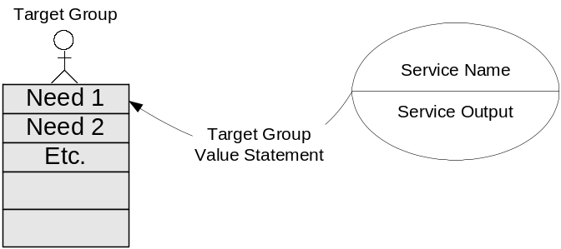
A rectangle represents each program in the model, and one or more service symbols (ellipses) is placed inside the rectangle, representing the fact that the program administers the service. Each ellipse shows the name of the service and the name of the service output. Only the services providing outputs to program target groups are identified.

Any target group recognized by the program(s) in the model is placed on the diagram using a figure, and a table below the figure lists the need(s) recognized by the program.

The service output vector is drawn from each service to every target group that experiences an intended benefit either directly or indirectly – the arrow goes directly to the specific need(s) addressed. A statement expressing the value of the output from the perspective of the target group member is placed on the vector.

The following example is an illustration of the approach for Secure Channel, using several selected services. It is not intended to be complete, or fully detailed.

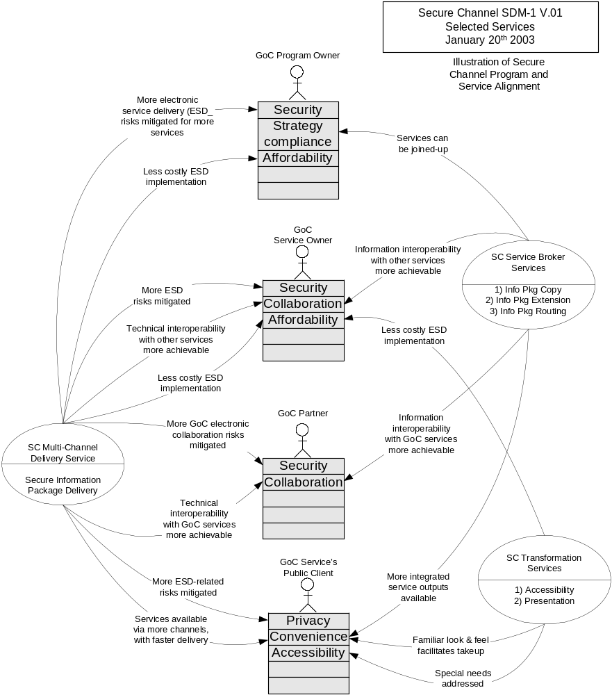

Secure Channel Performance Model Example

The Performance Reference Model is another in the set of strategic reference models defined by the GSRM. It provides a consistent method and framework for organizing the performance metrics for programs and services.

A metric is a description of a measure – what is to be measured; the actual measure taken can be the same, or a proxy. The Performance Model organizes and rationalizes the metrics for a program, its services, and the processes and resources used by the services. It classifies metrics according to definitions of efficiency, quality and effectiveness (EQE).

An extract of the Performance Model on the next page illustrates metrics for several services, drawn from for the Network and Security services in the Secure Channel service model (SDM-2). The table columns are organized as follows:

No. – refers to output numbers in the model
Output Name – refers to output name in the model
Output Description – describes the output in the model
Value – the value statement from the perspective of the party or target group ordering the output (this should be the same as the value statement in the PSAM model for that target group)
Service Output Type – one of the GSRM output types, from which a pattern of performance metrics can be drawn if available.
Performance Metrics – definition of EQE performance metrics for this service, developed directly or by adapting the general pattern for the type of output to a specific service output

Extract of Secure Channel Performance Model – Services
No. | Output Name (from SC SIAM) | Output Description | Value | * Service Output Type (GSRM) | Service is Accountable for:
 |  |  |  |  | Efficiency Metrics: value of service output over cost of inputs | Quality Metrics: comparison to service level output standards | Effectiveness Metrics: output fitness and contribution to program outcomes
5 | Delivered Application Information Package | Package of application information delivered from sender to receiver via multiple channels. | Technical interoperability with other services more achievable (Service Owner) | Movement | Application information package delivery unit costs | Application information package delivery reliability, accuracy, timeliness, availability, reach | Business impacts on application of information package delivery reliability, accuracy, timeliness, availability, reach
6 | Channel Session | Use of a channel to deliver application information package | Less costly ESD implementation (Service Owner) | Unit of resource | Channel session unit cost; target vs. reached population per capita costs | Channel reach/coverage, reliability, availability, capacity, reach, response time, speed | Channel takeup; channel features, capabilities and fitness compared to requirements
7 | Secure Channel Session | Use of a secure channel to deliver application information package | More ESD risks mitigated. (Service Owner) | Unit of resource | Secure channel session unit cost; target vs. reached population per capita costs | Secure channel protection levels, reach/coverage, reliability, availability, capacity, response time, speed | Channel trustworthiness and takeup; channel features, capabilities and fitness compared to requirements

The Performance Model illustration demonstrates the essential differences in performance metrics according to the type of output a service produces. (Appendix 3 lists the current GSRM output types).

The Multi-Channel Delivery service’s output is a delivered package of application information, and its output type is classified as a “movement”. The quality metrics for any movement will always include such things as: delivery reliability, accuracy, timeliness, availability and “reach” of the service in terms of pickup and delivery locations.

The Regular Channel and Secure Channel services’ outputs are “uses” of the channel, or channel sessions, and are classified as “units of resource”. The quality metrics for any “resource” will always include: resource reliability, availability and capacity (e.g. volume limits, response time limits, speed limits). The quality metrics for the Secure Channel must demonstrate the additional levels of protection available compared with the “Regular” channel service.

More general information on the Performance Model can be found in Appendix 2. The complete model of service performance metrics for SC Network and Security services, derived from the Network and Security services modeled in SDM-2, can be found in Appendix 4.

Extract of Secure Channel Performance Model – Services

Possible Next Steps

The assumption underlying these is that the common IT infrastructure models will be used as part of on-going business design and implementation review.

- Validate the SC service model (SDM-1). Update the SC service model to reflect decisions made in builds subsequent to ADS Volume 1 design. Develop additional details in the model to support business design reviews.

- Transition these models into the Secure Channel Governance Structure as the official business scope document. This would require defining and implementing alignment procedures, timelines and roles.

- Validate the Other Common IT Infrastructure service model. Align with Secure Channel model to support transition planning.

- Develop Secure Channel program and service alignment model (SDM-2) in areas where justification is not complete or questionable.

- Complete and validate the Performance Model of Secure Channel to confirm reporting requirements.

Appendix 1 - GSRM Definitions of Program and Service

Program

A mandate to achieve outcomes – to recognize and address specified needs of designated target groups within a jurisdiction and bring about desired improvements according to principles and strategies. The mandate expressed by a program is conferred by the public and established by legislative or administrative authority.

Service

A means of providing a valued output by expending resources to carry out processes in response to explicit or implicit requests by eligible parties. Services are administered by programs and contribute to program outcomes by addressing specific target group needs.

Appendix 2 – Program and Service Modeling

Program and service models are a method for creating useful business models or designs of public sector enterprises. The traditional business model describes business processes and is used successfully for detailed business and automation design. Business process models are not generally suitable as a system of record for the whole enterprise because of their rate of change, high cost of maintenance and the fact that they do not offer insights into strategy and policy.

Rather than business processes, GSRM methods model programs and services using formal definitions for both that correspond to their essential use in government. These elements are important to policy and program managers, and by using patterns, hide the complexities and details of business processes models without sacrificing any analytic power.

The result is called a Service Design Model or SDM. There are several forms or views of the model, depending on what aspects are being modeled or presented; these are described briefly in the following:

SDM-2: Modeling service integration and accountability.

This model creates a formal view of a group of inter-related services. In diagram form, an ellipse stands for a service and all its processes, and an arrow (called the output vector) stands for the final valued output of the service. Outputs must be validated against a set of standard output types as part of “leveling” them correctly.

The arrow can go to either the public or another service but not both. Only one output can be identified for a service, and it must go to multiple independent recipients in order to justify the existence of the service.

An arrow in SDM-2 does not represent the flow of anything between the two parties – it stands for an explicit or implicit service level agreement between the parties called horizontal accountability. To illustrate, this diagram states that the License Service is accountable for the License output and performance measures, and the Internet Service for the Internet Session output and performance measures.

Service Design Model (SDM-2)
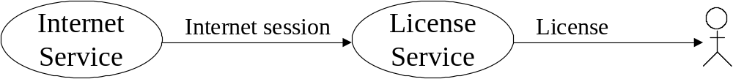

Contrast this with the following business process model of the same work that does in fact model the flow of information and other resources between parties:

Business Process Model (conceptual)



Both models encompass the same information, but the service model is more strategic, can be prepared using patterns to outline processes and information, and guides the development of more detailed models during implementation.

SDM-2 represents the enduring aspects of all services in a given scope efficiently, emphasizing their outputs and inter-service relationships. It traces the chain of accountability back from the ultimate clients. It rationalizes all services in the scope, again by using patterns to identify redundant processes occurring in multiple services so the business designer can propose additional services to supply those common outputs to achieve economies of scale.

A summary of formal SDM-2 modeling rules can be found at the end of this document.

SDM-1: Modeling progam and service alignment

SDM-1 creates simple consistent views of one or more related programs and their services, showing the target groups and needs each program recognizes. The graphic style for SDM-1 is pictured in the following example of two programs with overlapping target groups.

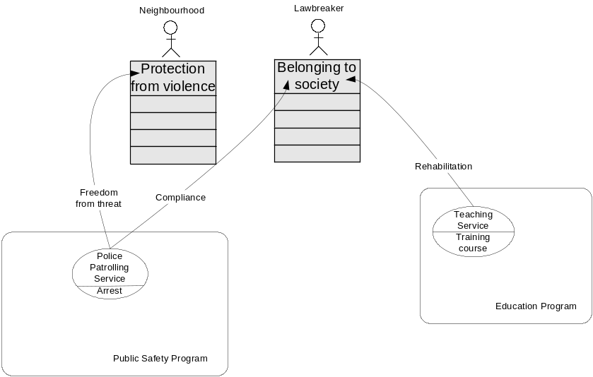

A rectangle represents each program in the model, and one or more service symbols (ellipses) is placed inside the rectangle, representing the fact that the program administers the service. Each ellipse shows the name of the service and the name of the service output. Only the services providing outputs to program target groups are identified.

Any target group recognized by the program(s) in the model is placed on the diagram using a named figure, and a table below the figure lists the need(s) recognized by the program.

The service output vector is drawn from each service to every target group that experiences an intended benefit either directly or indirectly – the arrow goes directly to the specific need(s) addressed. A statement expressing the value of the output to the target group member is placed on the vector. These statements are the intended outcomes of the program, defined as a desirable trend in the level of need that can be controlled by the program.

Various forms of alignment analysis should be performed in the development of this model – examples being:
- Are the target groups defined the same way by the services and programs?
- Are the policies governing eligibility or membership in each target group consistent?
- Are the value statements “made” by each target group aligned with the intended outcomes of the program; more specifically, will the production of the output produce the desired trend in the level of the need?
- Are all the recognized needs addressed?
- What are the impacts of the aggregate outputs from different services addressing the same target group need?
- What are the impacts (both positive and negative) of achieving program outcomes, defined as the potential consequences beyond the direct control of the program?

Developing the Program Service Alignment Model is the opportunity to align policy concepts, such as distinguishing between a need and a requirement, or between the needs recognized for individuals and the needs recognized for organizations and groups. SDM-1 is a simple an consistent approach for aligning vocabularies, taxonomies, policy views (target groups, needs, outcomes, value statements) and work views (outputs) of one or more programs, and the results can be used in more detailed models.

PRM: Performance Reference Model

Developing a Performance Reference Model in a systematic way ensures the completeness and integrity of business design, because the clarity of program and service definition and design is directly related to the clarity of understanding of what to measure.

This can be expedited with a Performance Model by recognizing and using patterns for measuring outputs according to their type. For example, the pattern of performance metrics for an output classified as a movement is profoundly different than the metrics pattern for an output that is classified as a resource, permission, etc. The Performance Model applies the following general definitions to programs, services, processes and resources:

- Efficiency Metrics
  - Value of results compared with cost of inputs
  - Applies to resource outputs, process outputs, service outputs, program outcomes
- Quality Metrics
  - Comparison of results to an explicit standard
  - Applies to resource (design) standards; process (practice) standards, service (level) standards, program (outcome) standards
- Effectiveness metrics
  - Contribution of results to the next (higher) level
  - resources → processes → services → programs → enterprise

An example illustrates the approach:
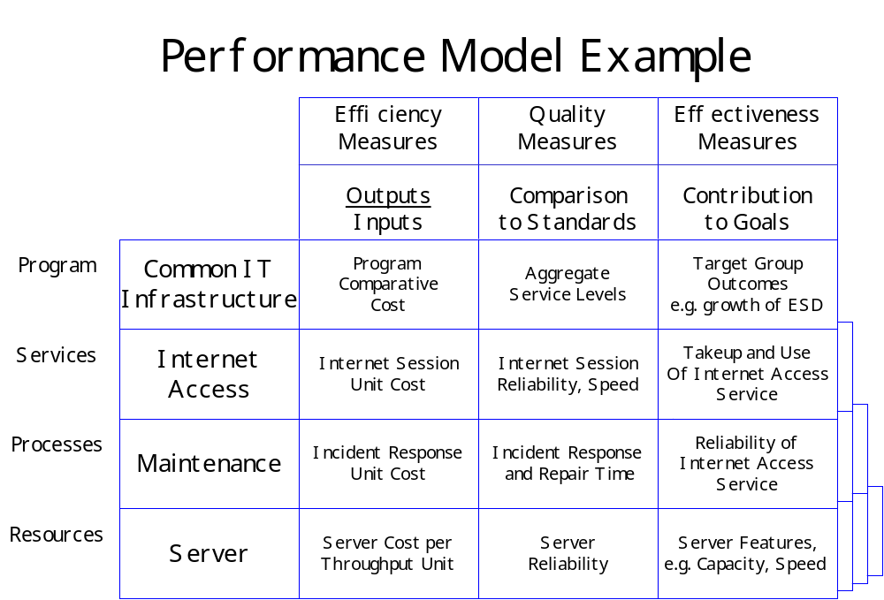

This notional model demonstrates the link between choice of server and growth of electronic service delivery in the enterprise. The value of the model lies in distinguishing and clarifying what program and service owners can be held accountable for, and how that should be measured in principle and in practice.

The general model below defines the relationships between metrics; a link between two metrics defines the direction of influence.

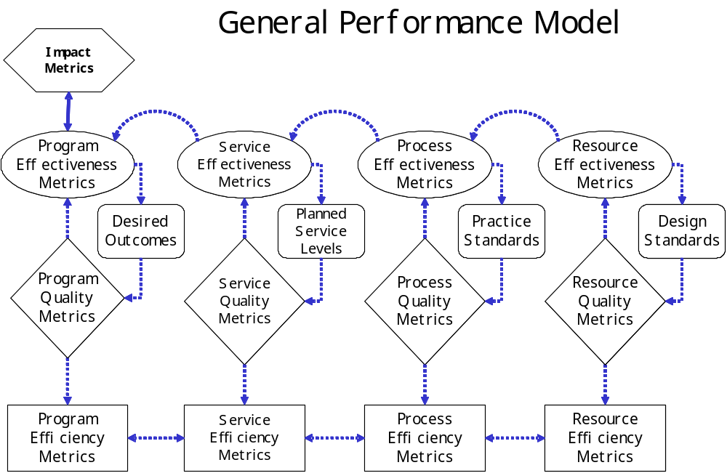

To illustrate, if a resource design standard is changed to address an effectiveness issue, the resource quality will go up or down accordingly, simultaneously influencing both resource effectiveness and resource efficiency.

A Performance Model can have important follow-on benefits such as improved understanding of how different metrics for different services across the program relate logically to each other. Performance metrics lead to performance measurement definition and to the design of management information about the program. A Performance Model can improve the integrity of the information that will be used to determine actual performance and set targets.

Appendix 3 – GSRM Service Output Types

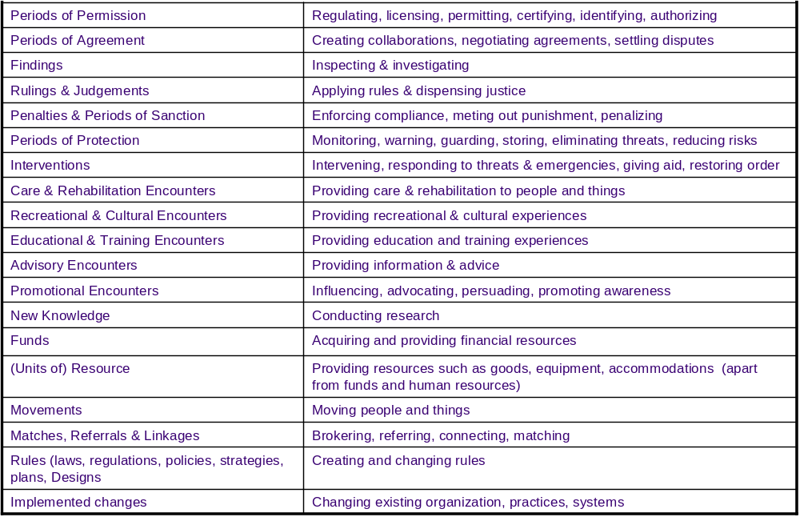
Output Types Corresponding Service Types

Appendix 4

Secure Channel Performance Model - Network and Security Services

(Refer to Page 1 of Secure Channel SDM-2)

No. | Output Name (from SC SIAM) | Output Description | Value | * Service Output Type (GSRM) | Service Provider is Accountable to Clients and Program for:
 |  |  |  |  | Efficiency Metrics: value of service output over cost of inputs | Quality Metrics: comparison to service level output standards | Effectiveness Metrics: output fitness and contribution to program outcomes
1 | Completed Application Transaction | A complete application transaction | Business process can proceed with confidence that application transaction is correct and free of risk | Advisory Encounter | Transaction unit cost | Application transaction safety and security, response time, reliability, accuracy, integrity | Business impacts of application transaction safety and security, response times, reliability, accuracy, integrity
2 | Application Hosting Session | A period of use of IM/IT infrastructure for application processing | Efficient and effective application hosting due to economies of scale | Unit of resource | Application hosting session unit costs | Application hosting features, reliability, availability, capacity, reach, response time, speed | Application hosting resource takeup; business impacts of application hosting features and fitness compared to requirements
3 | Secure Storage | A period of use of a secure electronic data storage facility | Data stored in the facility can be trusted to be safe from tampering and its availability guaranteed | Period of protection | Unit costs of secure data storage | Storage resource failure and exposure rates; storage resource security features, capability, reliability, availability, capacity, response time, speed | Business impacts of storage resource failure and exposure rates; business impacts of secure storage features and fitness compared to requirements
4 | Session Guidance | Directions and guidance (e.g. scheduling, contingency response) | Application service operation can be coordinated, efficient, effective | Management Process Output | Degree to which service output efficiency targets are met | Degree to which service output quality targets are met | Degree to which service output effectiveness targets are met
5 | Delivered Application Information Package | Package of application information delivered from sender to receiver via multiple channels simultaneously. | Information can be delivered from a wide population of senders to a wide population of receivers, safely, correctly and conveniently | Movement | Application information package delivery unit costs | Application information package delivery reliability, accuracy, timeliness, availability, reach | Business impacts on application of information package delivery reliability, accuracy, timeliness, availability, reach
6 | Channel Session | Use of a channel to deliver application information | Information deliveries can be made reliably, efficiently and effectively | Unit of resource | Channel session unit cost; target vs. reached population per capita costs | Channel reach/coverage, reliability, availability, capacity, reach, response time, speed | Channel takeup; channel features, capabilities and fitness compared to requirements
7 | Secure Channel Session | Use of a secure channel to deliver application information | Information senders and receivers can trust the correctness and safety of an information delivery; information deliveries can be made reliably, efficiently and effectively | Unit of resource | Secure channel session unit cost; target vs. reached population per capita costs | Secure channel protection levels, reach/coverage, reliability, availability, capacity, response time, speed | Channel trustworthiness, perception of trustedness and takeup; channel features, capabilities and fitness compared to requirements
8 | Completed Information Delivery Log Entry | Evidentiary data about application information delivery event | Log entries can be used to confirm information delivery and recover from errors and contingences | Period of protection | Log entry unit cost; target vs. reached population per capita costs | Log entry coverage, standardization, accuracy, availability and accessibility | Log entry trustworthiness perception; impacts of low coverage and errors; fitness to requirements (e.g. fitness for recovery from contingencies)
9 | Postmark | Evidentiary data about place of origin and reception of an application information delivery event | Postmark can be used to confirm information delivery and recover from errors and contingencies | Advisory encounter | Postmark unit cost; target vs. reached population per capita costs | Postmark standardization, accuracy, availability and accessibility | Postmark fitness to requirements
10 | Timestamp | Evidentiary data about time of sending and receiving of an application information delivery event | Timestamp can be used to confirm information delivery and recover from errors and contingencies | Advisory encounter | Timestamp unit cost; target vs. reached population per capita costs | Timestamp standardization, accuracy, availability and accessibility | Postmark fitness to requirements
11 | Digital Signature | Evidentiary data about source of an application information delivery | Information receiver can trust the origin of an electronic document | Period of protection | Digital signature unit cost; target vs. reached population per capita costs | Digital signature standardization, availability and accessibility | Digital signature trustworthiness perception and impacts
12 | Encryption | Transformation of an application information package between encrypted and decrypted states | Information sender and receiver can trust that delivery cannot be intercepted and tampered with or used | Period of protection | Encryption unit cost; target vs. reached population per capita costs | Encryption strength, standardization, availability and accessibility | Encryption trustworthiness perception and impacts, fitness to requirements
13 | Identity Authentication | Guarantees trustedness of sender persona identity to receiver and vice-versa in an application information delivery | Information sender and receiver can trust correctness of information delivery; trustedness can be established efficiently and effectively | Period of Protection | Identity authentication unit cost; target vs. reached population per capita costs | Coverage of information delivery events; percentage of erroneous authentications; authentication response times, speed and convenience | Impacts of low coverage and erroneous authentications; impacts of authentication response times, speed and convenience; fitness to requirements
14 | Grant of Access Permission | Grants persona permission to use application on owner’s delegated authority and to deliver application information to receiver on sender’s delegated authority | Application owner can safely delegate access permission granting; information sender can safely delegate delivery permission granting; grants of permission can be performed conveniently and efficiently | Period of Permission | Grant of access permission unit cost; target vs. reached population per capita costs | Coverage of sender and receiver and application owner and user populations; percentage of erroneous grants or denials of permission; permission granting convenience, simplicity and speed (e.g. number of distinct permissions required) | Impacts of low coverage and erroneous grants or denials of information delivery permission; impacts of permission granting convenience, simplicity and speed; fitness to requirements
15 | Registered Information | Guarantees identity of persona and validity of related information about that persona | Person’a identity and related information can be trusted; information about persona from different sources can be collected efficiently and can be integrated | Period of Protection | Registered information unit cost; target and reached population per capita costs | Percentage of fraudulent identities; information standardization, currency, accuracy, availability, accessibility | Degree to which information can be trusted and perception of trustedness; usefulness of integrated information about persona from different sources; fitness to requirements

Appendix 5

Secure Channel Implementation Analysis - Network and Security Services

(Refer to Page of Secure Channel SDM-2)

No | Service Name | Output Name | Service Description  (“Contracts to…”)  or Service Group Entry Name | JB Notes | Implementation?  (Y/N/Deleted or F(uture build) | Internal Takeup (own use by program) (Y/N) | External (program client) Takeup (Y/N or Named Instance) | Re-Usable Implementation (Y/N or Comment)
4 | SC Session Management Service | Session Guidance | Manage client channel session | SC manages its part of the session, but not the client session | Y | Y
5 | SC Multi-Channel Delivery Service | Delivered Information Package | Deliver package of information via one or more channels
 |  |  | WEB | ADDED | Y | Y | CCRA ACO, HRDC ROE  Epass | R
 |  |  | e.mail | ADDED | N-F
 |  |  | SC Wireless Channel Service | From 7 | N-F
 |  |  | ? Phone Channel Service | From 7 | N-F
6 CAT | SC Regular Channel Session | Regular Channel Session | Provide Secure channel connection path
 |  |  | SC VPN Protection Level A Channel Service |  | Y | Y | Y | R
 |  |  | SC VPN Protection Level B Channel Service |  | Y | Y | Y | R
 |  |  | ? SC “Secret” Channel Service |  | N-D
12 | SC Encryption / Decryption Service | Information Package Encryption / Decryption | Encrypt or decrypt information package |  | Y | Y | CCRA ACO  HRDC ROE  ePass | R
7 CAT | SC Secure Channel Session | Secure Channel Session | Provide channel connection endpoints
 |  |  | SC Internet Channel Service |  | Y | Y | Y (18 GENet clients for 02-12, the rest in 03, plus SC clients RC, CCRA, HRDC) | R
 |  |  | SC Intranet Channel Service |  | Y | Y | Y (18 GENet clients for 02-12, the rest in 03, plus SC clients RC, CCRA, HRDC) | R
3 | SC Secure Store Service | Secure Storage Period | Save information safely for channel switching |  | N-F
24 | SC Monitoring Service | Period of Protection | Provide monitoring and interventions
 |  |  | SC Virus Protection Service |  | N-F
 |  |  | SC SPAM Protection Service |  | N-F
 |  |  | SC Unauthorized Access Protection |  | N-F
 |  |  | SC Denial of Service Protection |  | N-F
 |  |  | SC Malicious Code Protection |  | N-F
XX | SC System Event Logging |  |  | The following 8, 8a,10, are a group
8 | SC Logging Service | Information Package Delivery Log Entry | Provide evidence of information package delivery |  | Y | Y |  | R
8a | SC Serial Number Service | Information Package Serial Number | Provide a serial number for each delivered information package | For brokered services | Y | Y
10 | SC Time Stamping Service | Information Package Delivery Timestamp | Provide evidence of time of information package delivery | For brokered services | Y | Y
XX | SC Non-Repudiation Service
11 | SC Digital Signature Service | Information Package Digital Signature | Provide evidentiary signature for information package delivery |  | Y |  | CCRA ACO,HRDC ROE, ePass | R
 | SC Non Repudiation Service | Stored information packages | SC Non-Repudiation Protection | WAS INSIDE 24 | Y |  | CCRA ACO,HRDC ROE, ePass | R
13 | SC Identity Authentication Service | Identity Authentication | Authenticate identity of information package sender or receiver (human or system)
 | ID - Proving | Identified Candidate | Establish first time identity | This is Dept Stuff | N-D |  | CCRA ACO, HRDC ROE | A  Program Specific
 | Issue Credential | Credential (PKI Cert) | Issue credential for repeatability |  | Y | Y | CCRA ACO, HRDC ROE | R
 | Credential Authentication | Grant of Access to GOL | Authenticate credentials of information package sender or receiver |  | Y | Y | CCRA ACO, HRDC ROE | R
 | Enrolment Authentication | Grant of Access to Program | Grant of access to dept GOL program |  | N-D |  | CCRA ACO, HRDC ROE | A  Program Specific
14 CAT | SC Authorization & Privilege Management Service | Grant of Access | Grant of access to information package sender or receiver, or application user | SC might provide the infrastructure, but this is dept stuff | Infr: N-F  Authr N-D
 |  |  | SC Information Delivery Permission Instances |  | Infr: N-F  Authr N-D
 |  |  | SC Application Access Permission Instances |  | Infr: N-F  Authr N-D
15 CAT | SC Registration Service | Registry Information | Provide registry information
 |  |  | SC Identity Registration Service | This is mapping | N-D |  | CCRA ACO, HRDC ROE | A  Program Specific
 |  |  | SC Credential Registration Service | This is the CA | Y | Y | CCRA ACO, HRDC ROE | R
 |  |  | SC Authorization Registration Service |  | Infr: N-F  Authr N-D
 |  |  | SC Privilege Registration Service |  | Infr: N-F  Authr N-D

Appendix 6:

Comparing the Service Broker and ebXML Using a Service Model

Synopsis

This paper analyzes the specific business design of the Service Broker – a group of services offered by Secure Channel to automate business collaborations between parties – and contrasts that with an alternative business design enabled by using ebXML, an international standard with the same objectives.

The analysis finds that compared with the Service Broker, the underlying paradigm of ebXML has the potential to address more collaboration needs of the GoC and could create more efficient and more effective collaborations in general - within the GoC and between the GoC and other parties. The conclusion is that the Service Broker business design should be reviewed in light of ebXML.

Service Broker Business Design

The Secure Channel (SC) business design, represented in a service model prepared according to FAP2 standards, contains three distinct business services collectively called the Service Broker. These services enable collaboration among parties using them. Only operational services appear in this model – those that are used by clients at their fulfillment time. Provisioning and stewardship services used to establish conditions for fulfillment are not shown.

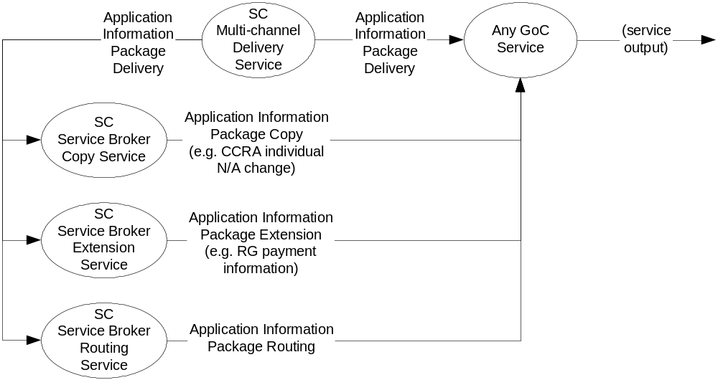

The fragment of the Secure Channel model shown above illustrates the Service Broker outputs from the perspective of any service that is a client of the Secure Channel. The client may take up one or more Service Broker services in addition to the primary service - secure delivery of application information.

- The “copy” service will contract with any service to make a copy of an information package on route to another service’s application. The “copy” service uses its sister channel service to deliver that output. For example services can obtain copies of name and address changes destined for a CCRA service.
- The “extension” service will deliver a portion of an information package destined for one service to another service, plus additional (extended) information gathered at the second service’s request. The Receiver General’s Buy Button is an example – the payment service at the RG uses this Service Broker service to obtain payment data related to another service’s fulfillment.
- The “routing” service will route application information package deliveries sequentially between multiple services B, C, etc. at service A’s request. For example, the other Secure Channel services use this to route information packages for encryption and transformation.

Alternative ebXML-based Service Design

Using the same representational standard, the equivalent service model for an ebXML-based business design would appear as follows (once again, only operational services are shown):

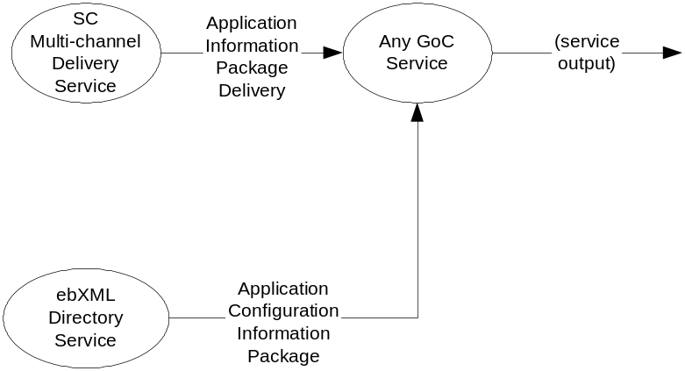

The ebXML Directory Service is a single service that provides information in a standard format (called a BPSS or business process specification schema) to configure the applications of two or more services so they can exchange information directly using the channel service at their fulfillment time. To implement the distribution of name and address changes described above for example, both CCRA and a subscribing service would request information about each other’s collaboration process from the ebXML Directory Service and use it to configure their applications. CCRA’s application would then use the channel service to send a copy of the name and address information directly to the subscriber’s application.

Business Design Analysis

The context for this analysis is the concept that the Secure Channel is a common IT infrastructure program that addresses GoC needs for economic efficiency, and collaboration through interoperability.

Efficiency of design

The first comparison is design efficiency, interpreted broadly to mean how well can scale economies be captured for the GoC.

If its design is general, Service Broker efficiency will be high and scale economies will be at a maximum. New client takeup could cause additional provisioning of Service Broker services but no additional design and implementation. To put this in context, a new subscriber to the “name and address” information package could use the same “copy” service implementation as previous subscribers, and a new information package – say aircraft licensing data – could also use the same implementation. There are implementations of all three services now, but they have not been analyzed for this review to determine how general they are.

To the extent its design is not general or cannot be implemented in a general way, then the three services in the initial business design cannot be re-used beyond a specific output (e.g. copy of CCRA name and address change). The components used to construct the services may be re-usable, but the three services will not be, and will ramify and become 4, 5, 6, etc. - each with separate implementations, distinct resources, separate accountabilities, performance measures, etc. - adding to overall complexity and Service Broker cost. Scale economies would be reduced but not necessarily eliminated, depending on how many clients can use the same implementation.

The business design of the ebXML Directory service is by definition general – only one implementation is needed in theory although there may be several operated by different parties – say one or more operated for profit for global trading, one by the GoC for internal collaborations, one by security interests across North America for public safety collaborations, and so forth. (The means of coordination should this be a requirement are not known at this point.)

Summarizing, scale economies are in principle equally accessible using either approach– they are based on the number and size of the collaboration groups availing themselves of these services, and the intensity of their collaborations. Scale economies are primarily an objective for clients of the program to capture by identifying collaborations that have the potential for critical mass. The ebXML alternative can capture efficiencies on an international scale; the Service Broker can capture efficiencies on a GoC scale. The ebXML design only operates as a generalized service; the Service Broker design requires vigilance to ensure generality of its services and thus efficiency.

Efficiency of Implementation

The second comparison is implementation efficiency, meaning how much work is involved in taking up the services.

Under either approach a collaboration group will need to agree on the information to be shared or exchanged, then re-design and re-implement their business processes and applications as required. The group can be as small as two parties, or of any size subject to the capacity and capabilities of the underlying technology. A “market dynamic” is likely to occur, where more common collaborations will attract more participants, which will in turn attract more resources and support.

The ebXML design is intended as a global standard. The Service Broker design is specific to the GoC. All other things being equal, ebXML will lend itself to more collaborations and more collaborators, and is likely to attract more support – lowering the cost of takeup. One illustration of this is the observation that major COTS suppliers are more likely to build ebXML interfaces into their general applications than Service Broker interfaces. Purpose-built applications will also benefit – one ebXML interface may take the place of many Service Broker interfaces.

Effectiveness of Design – Functional Scope

The next question is whether needs recognized by the program can be addressed by the services provided. The general model of collaboration used by FAP2 is based on achieving three successive levels of interoperability:

- Technical interoperability – safe sharing and exchange of data is optimized by removing technical barriers to transmitting or accessing data shared with other collaborators.
Within the GoC, this level of interoperability is achieved by the channel and security services of the Secure Channel program, and is not a factor in comparing Service Broker and ebXML.
In collaborations beyond the GoC, where the Secure Channel may not be involved end-to-end, the ebXML design improves technical interoperability because it enables data to be exchanged directly between collaborating parties without requiring a flow through a third party for any form of ebXML-related storage and processing.

- Information interoperability (also called semantic interoperability) - sharing and exchange of meaning is optimized by removing barriers to shared understanding of the data by all parties to the collaboration.
Service Broker services are not intended to act directly to remove barriers to understanding (and would compromise their design generality if they did so). The assumption is that these issues will be addressed by the collaborators during implementation.
A related question is whether the three Service Broker services are sufficient to address all information interoperability needs – in other words, can all information exchanges between parties be deconstructed into the primitive steps of copying, extending and routing one party’s information. This question cannot be answered at this point, without more implementation experience (or a more fundamental model) to prove or disprove the claim, so this analysis assumes they are sufficient.
The ebXML Directory service also does not act to resolve semantic differences. However, XML communities (including many governments) have formed independently to create shared vocabularies and taxonomies in popular areas of collaboration. These specifications can be incorporated into and configure an ebXML Directory Service very quickly (the “plug and play” notion) because they are intrinsic to the ebXML concept. The work of these communities benefits the Service Broker design as well, but whether those services can be quickly configured in the same way is not known.
The size of these communities means resources will become more available to address semantic issues. An illustration of this is the availability of a modeling method (the United Nations Modeling Method or UMM) based on the Universal Modeling Language (UML) – this method is specifically aimed at designing business processes for ebXML-enabled collaboration.
The ebXML Directory Service is not as specific as the Service Broker services, so the question of sufficiency does not arise. It can bring about the same effects as Service Broker – sharing copies and extensions of information, and routing information – because it is a more general service. Following the same line of reasoning, it is more likely to be able to address unforeseen information exchange “primitives”.

- Business interoperability – optimizing the sharing of tasks and responsibilities, or the removal of legal, organizational and other barriers to acting in concert.
Service Broker services do not directly address legal or organizational barriers so their clients can act more in concert. In service modeling, services should be designed to conform to the mandate and jurisdiction of the program administering them, so this is not surprising. Other means have been suggested to facilitate business interoperability, such as a “middle” program to take accountability for common information, but this does not relate directly to Service Broker services.
The ebXML Directory Service does provide the means for parties to enter into legally binding commitments at the time of collaboration. This feature is important for business interoperability, and it is also one example of a larger capability in the ebXML Directory Service – the abstraction, standardization and specification of collaboration roles and processes. There is no equivalent capability in the Service Broker design.
As a consequence, the ebXML design is based on a concept of a collaboration as a multi-party, multi-step interaction across time – an example is the collaboration between a car owner and the car dealer for the lifetime of the vehicle. By contrast the Service Broker design is based on a concept of a collaboration as a point-in-time exchange of information (transaction), with the linkage between transactions maintained by clients.
In summary, the paradigm underlying ebXML is different from that of the Service Broker, with the result that many barriers to business interoperability may be avoided from the start, possibly even the issues favoring a “middle” program. The point is examined in more detail in a later section of this analysis.

Summarizing the functional designs, this analysis finds both Service Broker and ebXML to be equivalent in principle at enabling information interoperability, although ebXML can take better advantage of the XML-based communities of practice forming around the world. The ebXML design addresses business interoperability by standardizing collaboration roles and processes. The ebXML design addresses technical interoperability in collaborations beyond the GoC boundaries.

Effectiveness of Design – Targeting Scope

The next comparison is the scope and reach of the two designs. Since neither has an implementation that could be considered mature, this comparison is quite generic.

The Service Broker is not specific to the GoC – the working assumption is that there is no technical reason why the services could not be taken up by other parties collaborating with the GoC, although they will compete with other alternatives such as ebXML for resources. In its favour are the following: the needs within the GoC have priority; many collaborations are with other jurisdictions within Canada and can be influenced more directly; and the GoC directly controls the evolution of the services. Against it is the proprietary nature of the services, significant to collaborators outside the GoC.

The ebXML approach is intended to be a global standard, and is of specific interest to government because it is non-proprietary and UN-sponsored. The current state of development is not such as to guarantee adoption, but there are no compelling negative indicators at this point. In its favour are the greater generality of the design, intended to attract the widest possible audience (a very meaningful factor from the GoC perspective) and support, and the international nature of the effort, encouraging a national response. Against it from the GoC perspective is the fact that its evolution cannot be directly influenced.

In summary, the Service Broker’s design is not a sure thing, but unlikely ever to become more than a GoC standard. The ebXML design is not a sure thing but has the potential to become a global standard, and is most likely to converge with other initiatives addressing the same need. This is a classic situation, faced many times. There may be a template available to gauge the likelihood of success of an emerging standard, but in its absence, leadership is required.

Design Paradigms

The final comparison is not a typical service model analysis, but follows from the conceptualization of a service model, where patterns and abstractions become more recognizable.

The Service Broker and ebXML designs have different underlying collaboration “paradigms”, which will be called “1:N” and “N:N” respectively and which are illustrated in the following:
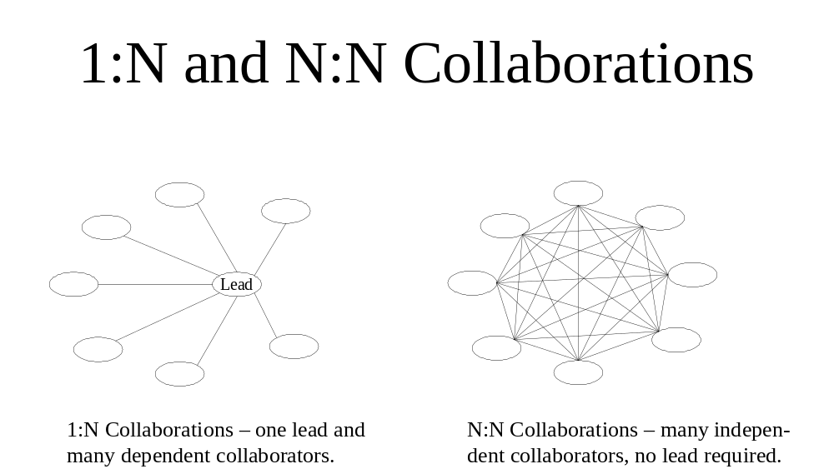

An important concept for the Service Broker is the lead – a department, program, etc. The lead does more than sponsor the inception of the collaboration – it plays a unique role in the ongoing functioning of the collaboration, witness the requirement for CCRA’s name and address application, so that other program can subscribe to it. The lead functions as an authority or prime mover in the collaboration, and the Service Broker facilitates this role, with its copying, extending and routing of the lead’s information. When this requirement produces problems – such as the custody of common information – a new program is the answer emerging from this paradigm.

There is no requirement for a functional lead and authority in the ebXML design (although one could be supported in the same manner as the Service Broker should the situation warrant it). The ebXML concept resembles a market in its operation. To put it in the same context as the Service Broker example, all potential collaborators could be both subscribers to and publishers of name and address changes – and the service learning of a Canadian’s change of address first could share that information with others who were prepared to take it from them. Some services might prefer the quality guarantee of the CCRA name and address change information, backed by its legislated authority to collect it, and the maturity of its systems; others might be content with earlier, less authoritative information; some might have a two-stage strategy, using the earliest information and confirming it later. The application of this concept to sharing information in a public safety or public health context is obvious.

Another paradigm-level difference shows up in implementing a collaboration. A simple model for this might have five steps – find (a collaborator), trust, agree, prepare, transact. The Service Broker paradigm is that all collaborations are premeditated (i.e. that these steps are all guided and determined by the lead), and that all five steps are separate, or at least some of the steps are outside Service Broker’s scope. The ebXML paradigm is that desirable collaborations can be unpremeditated, and all five steps can take place in an instant, and are all within the scope of the ebXML design. The relevancy of this can easily be imagined in a scenario where law enforcement agencies publish and subscribe to information about individuals and events, where a public health emergency is declared, or even when a community consultation takes place. In theory at least, in the law enforcement example a given agency, needing information about situation – a drug seizure say - could use the ebXML Directory Service to…

- locate all agencies willing to exchange information about some or all of the information about their drug seizures,
- determine whether to trust the located parties fitting the requirement (or not),
- enter into an agreement (or not) concerning the information to be exchanged about the particular situation of interest – in effect the common ground between both party’s policies and regulations, if any
- activate the application to process the information
- receive the information directly from the other party

… all in one automated step, perhaps in an instant, perhaps repeated many times over with different agencies about the same situation.

This can sound like a premeditated collaboration, and has been implemented that way many times. The important difference with the ebXML design is that the exchange may take place between agencies that have never had contact with each other in any form – they have only registered their willingness to exchange specific types of information with certain types of parties, and specified the details of their process for doing so in a standard form – in an ebXML directory.

The following table summarizes the paradigms underlying the two designs:

Service Broker Paradigm | ebXML Paradigm
The world is knowable and bounded:  - GoC-wide standards are enough  - GoC-centric interoperation is enough | The world is not knowable and bounded:  - international standards are a start
Collaborations are point-in-time exchanges of information. | Collaborations are complex multi-party, multi-step interactions across time, specifying information, processes and roles
Desirable collaborations are always premeditated  - Find, trust, agree, prepare, transact are two or more separate steps, at least one of which is outside the Service Broker’s scope. | Desirable collaborations can be unpremeditated  - find, trust, agree, prepare, transact can be one step
Centrally-enabled collaborations imply central accountability  - a “hub and spokes” model (1:N)  - the lead department or “middle” program is required | Collaborations can be centrally enabled without central accountability  - a peer-to-peer model (N:N)  - peer or joint or horizontal accountability can be trusted or is a reality

Two important points to remember in comparing these paradigms:

- the ebXML design includes the Service Broker design, i.e. both models can support 1:N, but the reverse is not true - the Service Broker is not designed to support N:N.
- the work involved in taking up services under the ebXML model is not greater than, and potentially less than, the Service Broker design.

Conclusions

This analysis has been strategic and has not addressed tactical considerations such as existing commitments to clients and timeframes. Nonetheless, the potential advantages of more general and more internationally-recognized services to enable collaboration are compelling. This analysis supports a review of the Service Broker, and a more detailed examination of an ebXML-based alternative business design.

The strict distinctions in modeling terms are between As-Is (defined as models of implemented services), To-Be (models approved for implementation) and Could-Be (models proposed for implementation). These distinctions could not be made based on the information available.
One concern expressed about ebXML directory services is that technology may not be available to support intense collaborations across global communities.
However, other Secure Channel services identified in the Common IT Infrastructure service model could play some role here, translating or transforming data between different frameworks.

